1. **Perform basic Image Handling and processing operations on the image• Read an image in python and Dilate an Image using Dilate function.**

**Aim:**

To Perform Basic Operations to Read Image and Dilate an Image using Python.

**Code:**

import cv2

import numpy as np

kernel = np.ones((5,5),np.uint8)

print(kernel)

path = "C:\\Users\\prith\\Documents\\CV\\cvimage.jpg"

img = cv2.imread(path)

imgGray = cv2.cvtColor(img,cv2.COLOR_BGR2GRAY)

imgBlur = cv2.GaussianBlur(imgGray,(7,7),0)

imgCanny = cv2.Canny(imgBlur,100,200)

imgDilation = cv2.dilate(imgCanny,kernel,iterations=10)

imgEroded = cv2.erode(imgDilation,kernel,iterations=2)

cv2.imshow('Eroded Image',imgEroded)

cv2.waitKey(0)

cv2.destroyAllWindows()

**Input:**

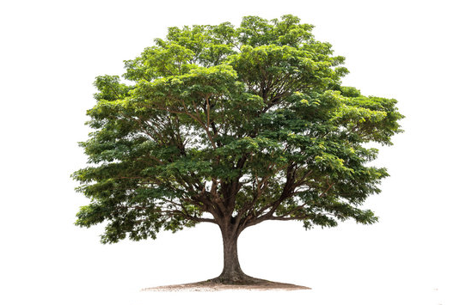

**Output:**

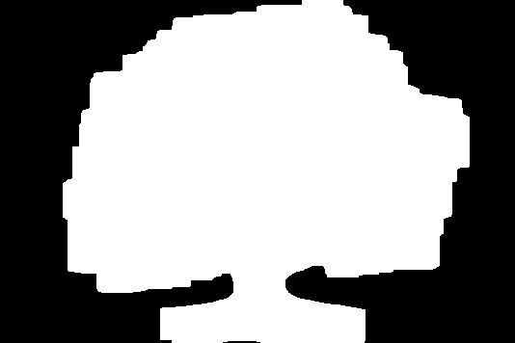

**Result:**

The python program to convert image to outline using dilate function.